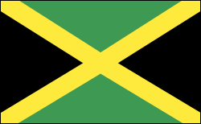 |  | Jamaica  - Government  - Issued 11/16/15
 |  | In This Issue

Constitutional parliamentary democracy

BACKGROUND: Jamaica is a parliamentary democracy governed under the constitution of 1962. It has a bicameral Parliament made up of a 21-member Senate and a 60-member House of Representatives. The prime minister is the head of government. The head of state is the British monarch, as represented by the governor-general. The country has two main political parties: the Jamaica Labor party
Bicameral Parliament House of Representatives
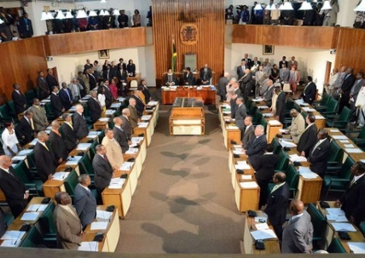
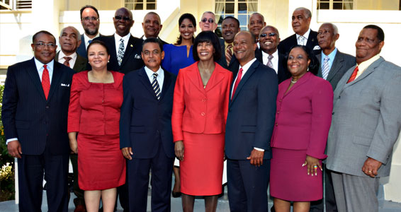

PRIME MINISTER: Similar to the president
